No. 8 – Lycian alphabet (Swiggers & Jennings 1996: 283)

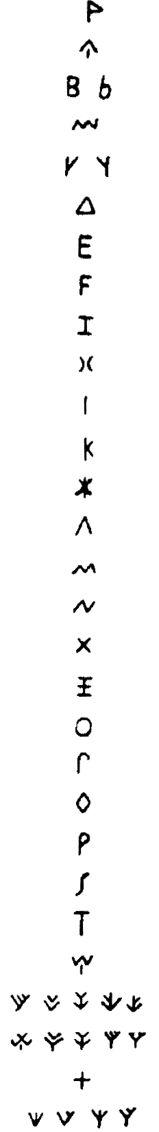

No. 9 – Aramaic alphabet (Jensen 1970: 301)

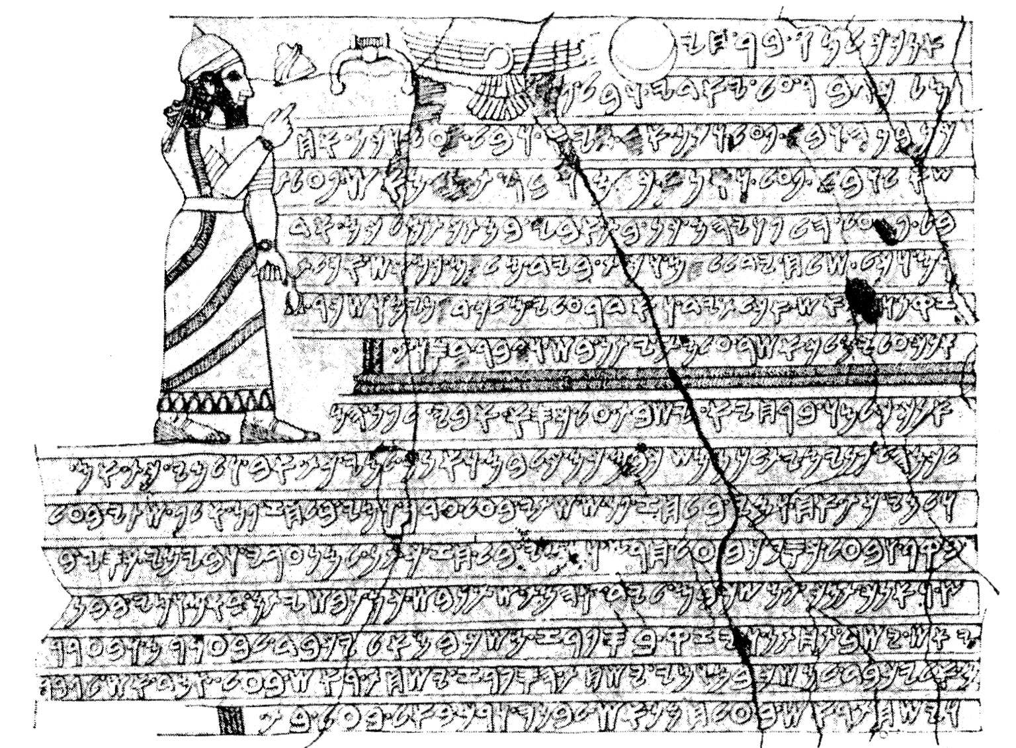

from Jerusalem,
1st century AD
from Palmyrene,
4th century AD

No. 10 – Pollard system (Zhou 2003: 316-321)
- original Pollard script
- reformed Pollard script (Roman)
- Pinyin-oriented Pollard script
- Reformed original Pollard script

Original Pollard - initials

Original Pollard - finals

Reformed Pollard system (1957)

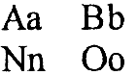
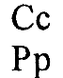
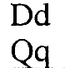
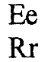
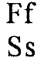
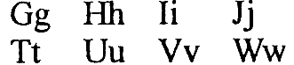
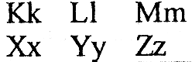

Pinyin-oriented Pollard system (1958)

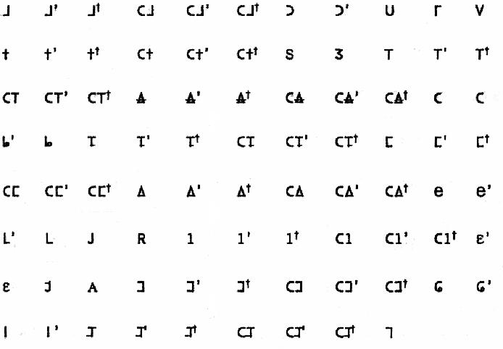

Reformed original Pollard (1998) - initials

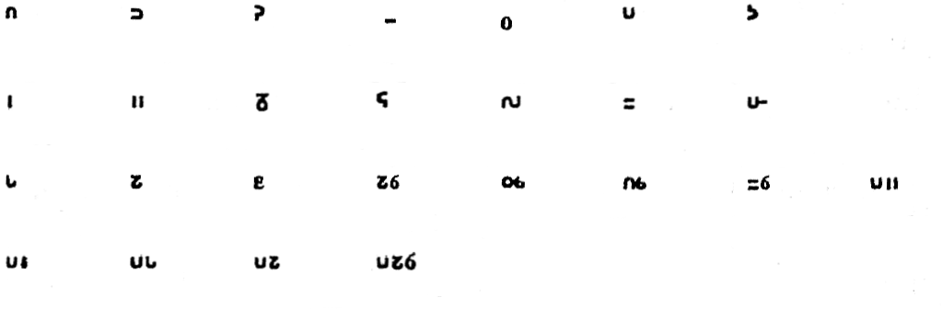
Reformed original Pollard (1998) - finals

Reformed original Pollard (1998) - tone symbols

No. 11 – Sequoyah script (Jensen 1970: 242)

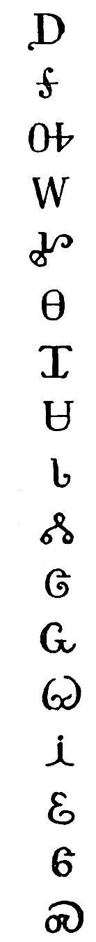
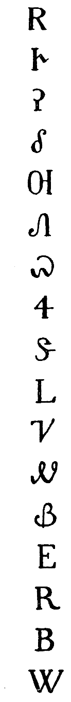
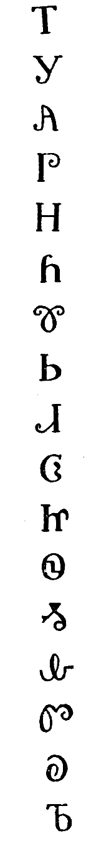
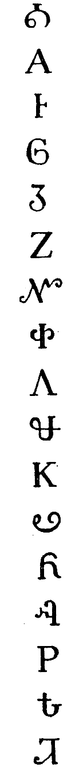
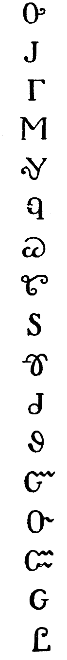

No. 12 – Inuktitut writing (Nichols 1996: 607)

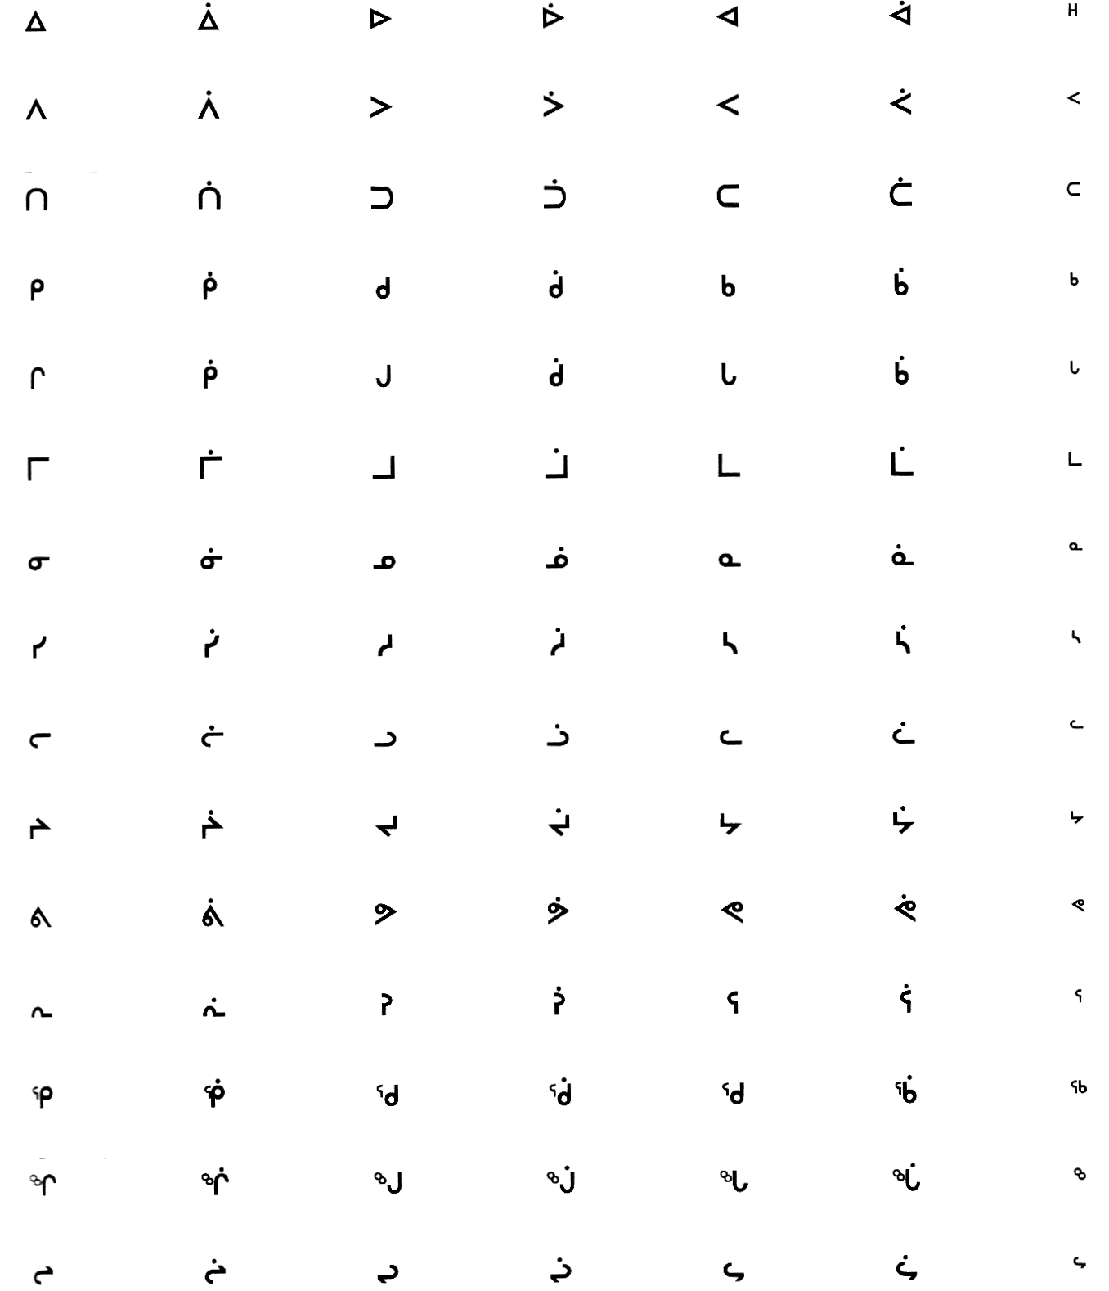

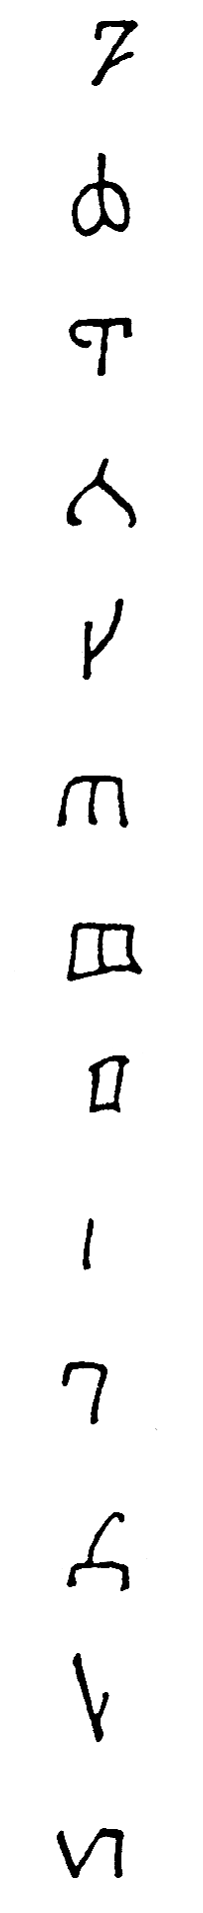
No. 13 – Abur alphabet (Haarmann 1991: 126)

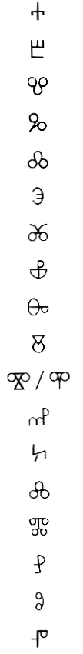
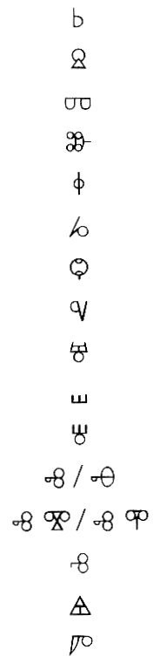
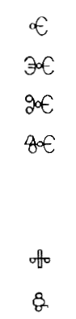
No. 14 – Glagolitic script
(Cubberley 1996: 348)

No. 15 – Etruscan writing (Jensen 1970: 516)
- Lepontic variant

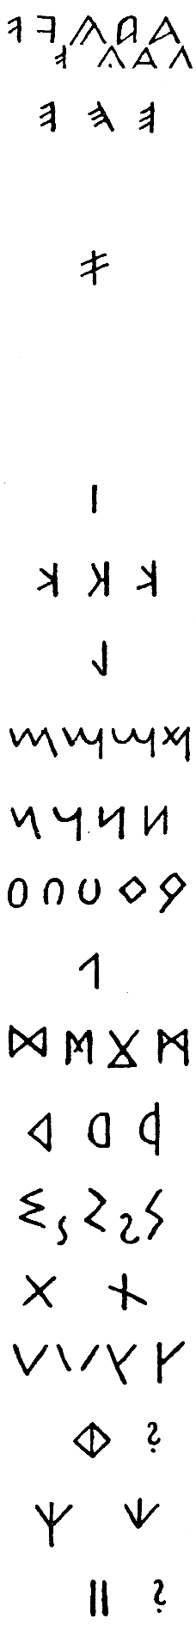

No. 16 – Iberian script (Haarmann 1991: 418)

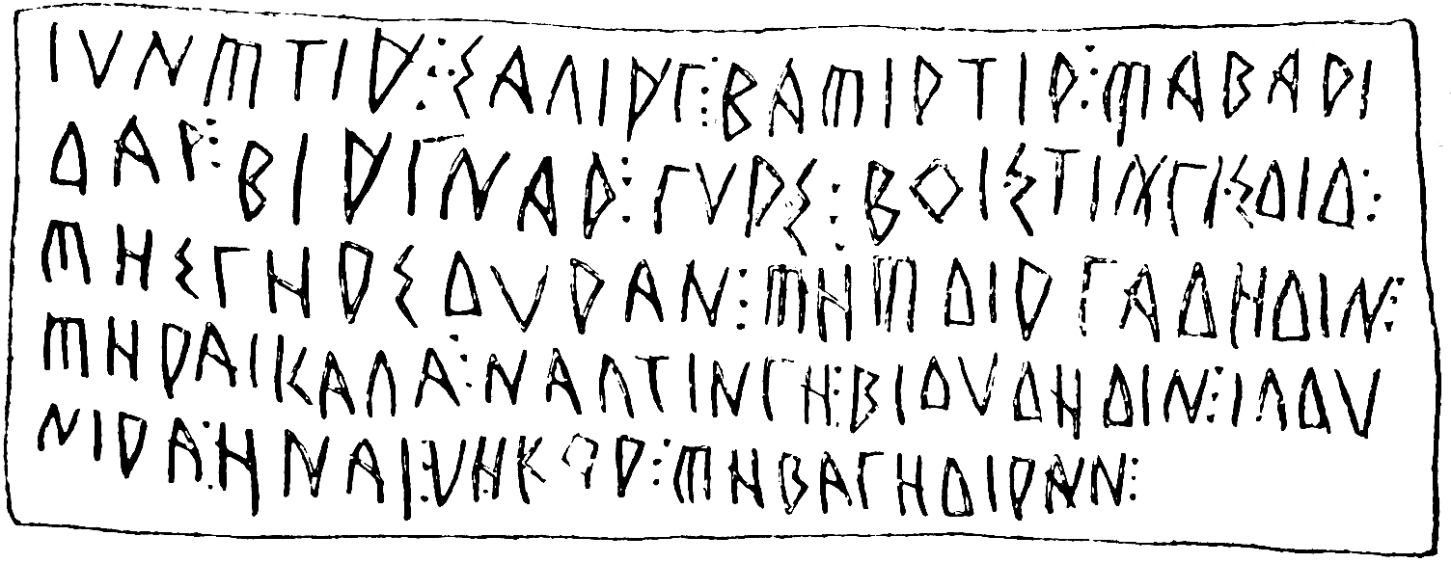

No. 17 – Kurdish writing (KAL online source)
- in Roman
- in Cyrillic

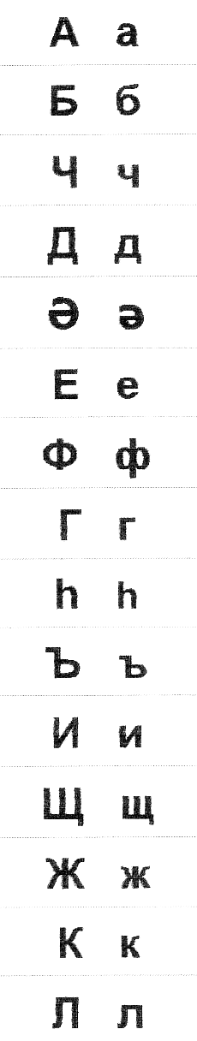
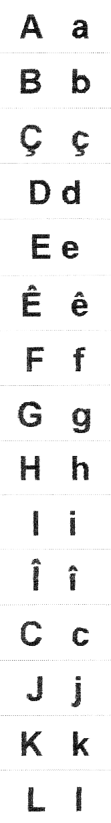

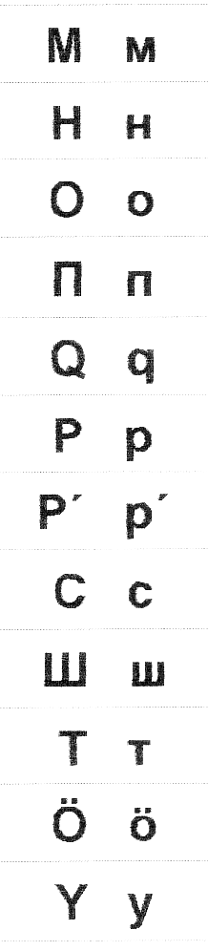
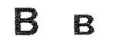
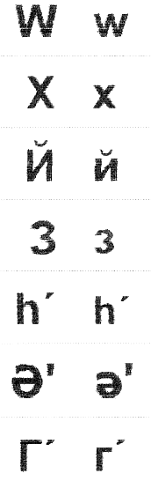
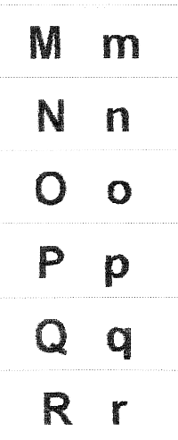

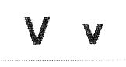
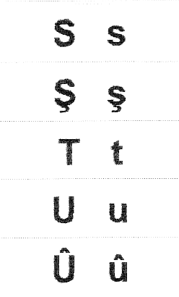
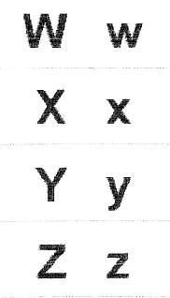

No. 18 – Ethiopic syllabary (Jensen 1970: 345)

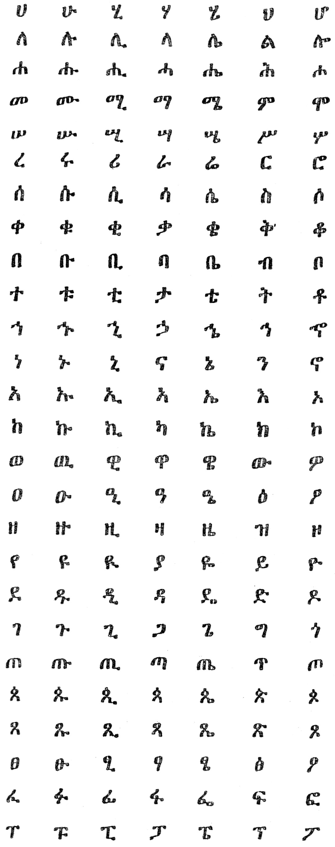

No. 19 – Deseret alphabet (Glück 1987: 261, 262)

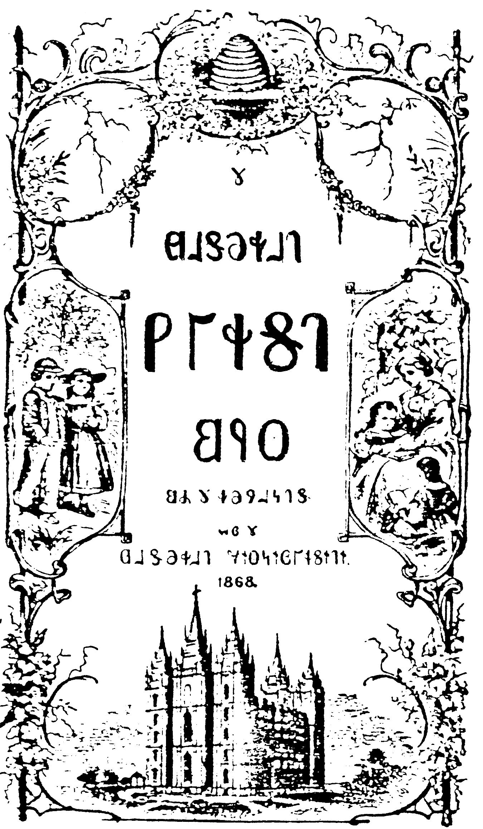

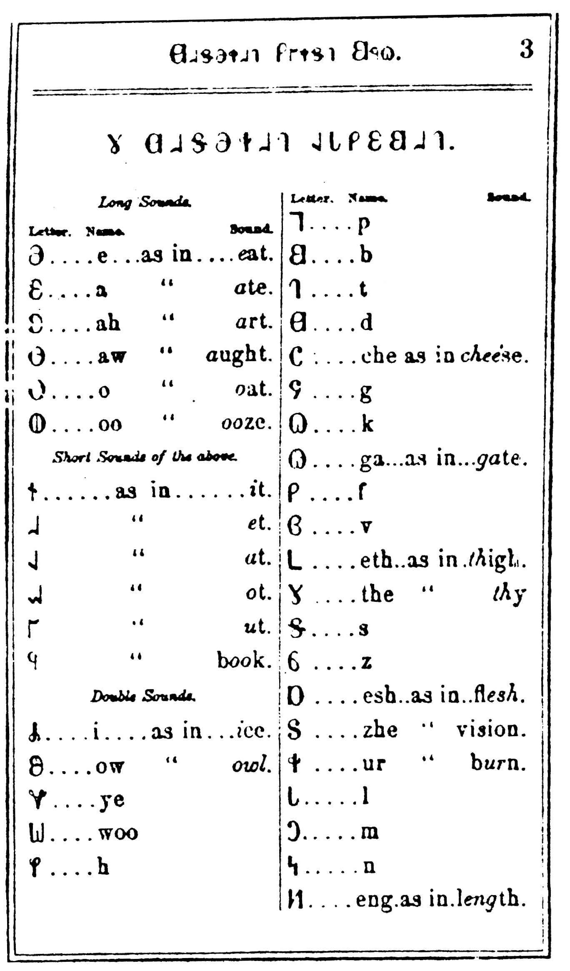

No. 20 – Japanese kana writing (Smith 1996: 211)
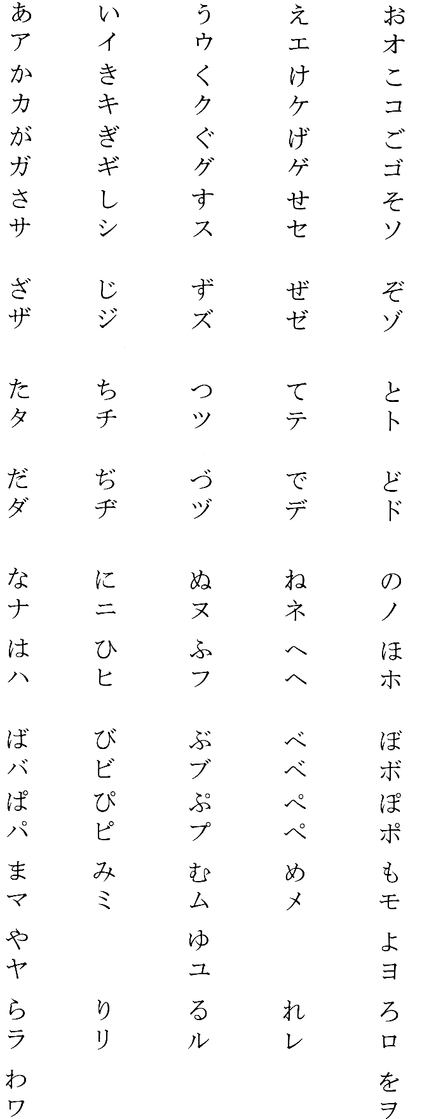

Hiragana: first
line and every
second
following one

Katakana: second
line and every
second following
one

No. 21 – Hangul (King 1996: 224)

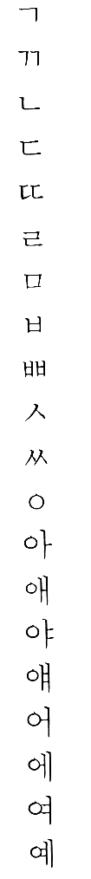
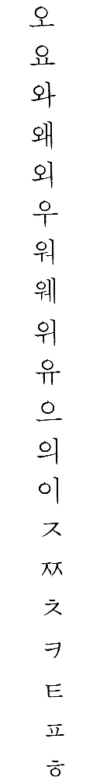

No. 22 – Egyptian writing (Haarmann 1991: 104, 105)
- Hieroglyphs
- Hieratic
- Demotic

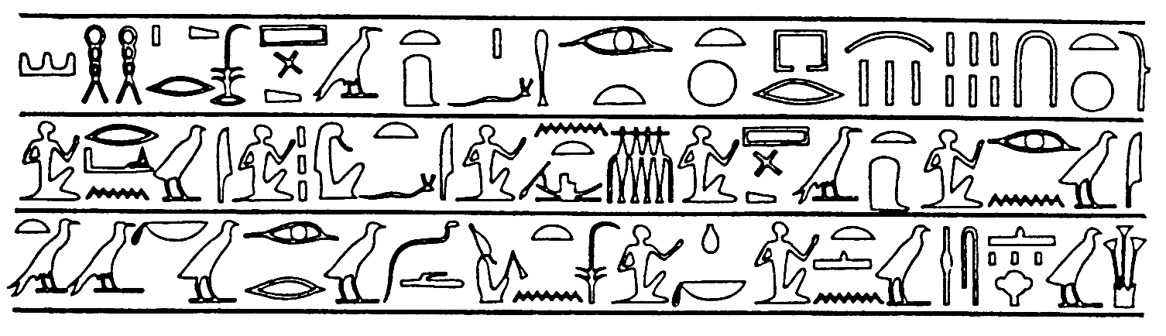
Hieroglyphs

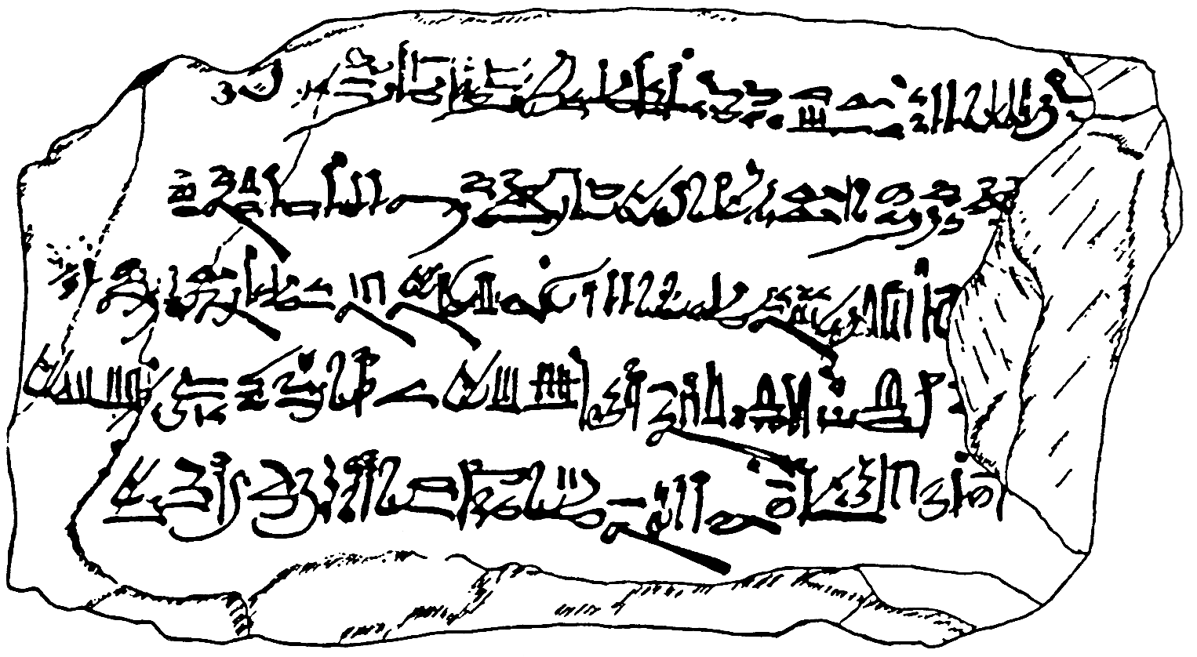

Hieratic

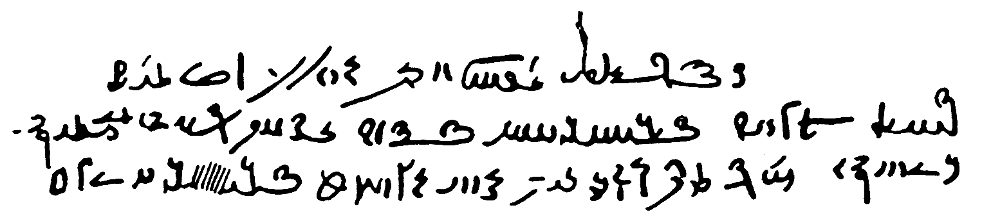
Demotic

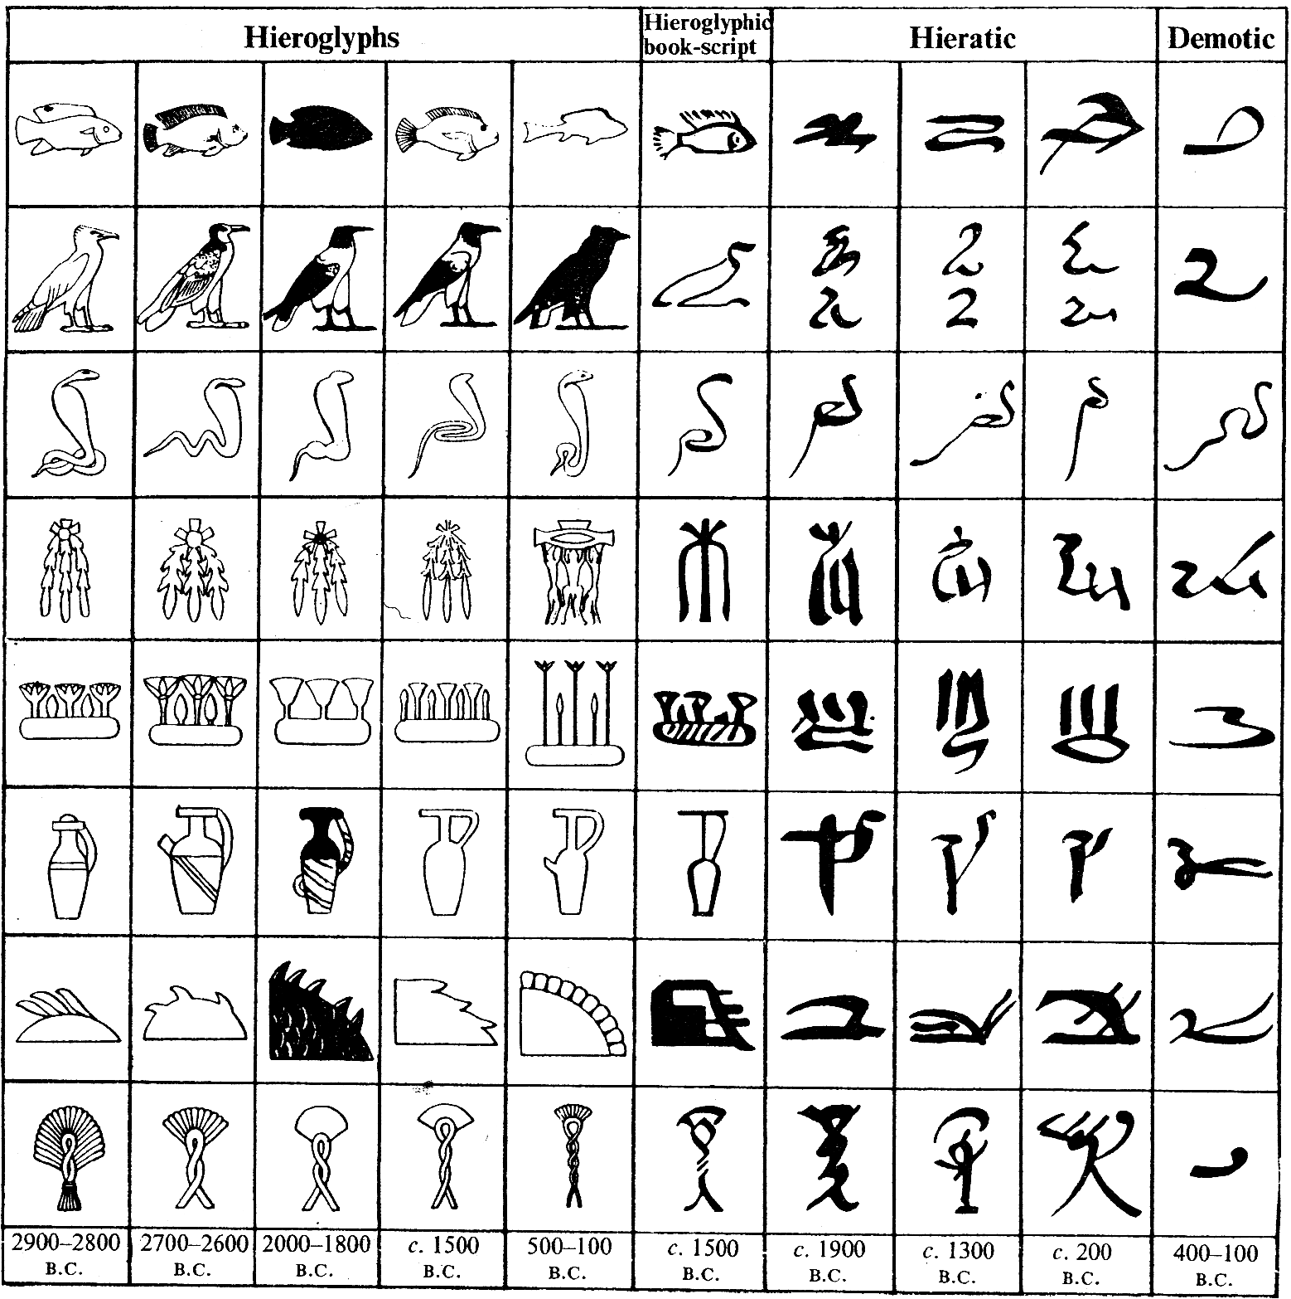
Evolution of the Egyptian scripts

